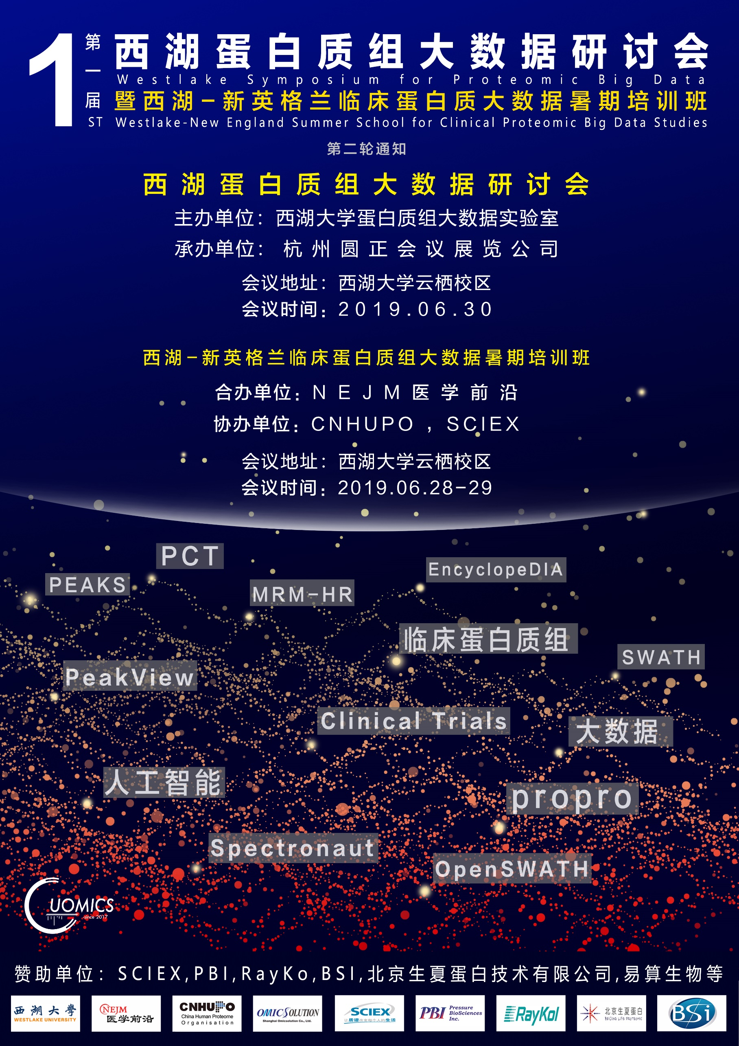

会议介绍
鉴于蛋白质组的高度复杂性及动态性，为了推动蛋白质组大数据的临床应用，实现临床蛋白能更好的服务于精准医疗，西湖大学蛋白质组大数据实验室将于2019年6月30日，在浙江省杭州市西湖大学举办“第一届西湖蛋白质组大数据研讨会” ，集中讨论近期发展迅速的DIA-MS技术的最新进展和临床应用，研讨内容具体包括临床蛋白质组大数据的产生、质控、分析和机器学习等。
本次会议由西湖大学蛋白质组大数据实验室主办，杭州圆正会议展览有限公司承办，会议以全英文形式开展。欢迎具有一定的质谱经验，对多种DIA技术感兴趣的科研人员和学生前来参加。
培训介绍
西湖大学蛋白质组大数据实验室将于2019年6月28-29日在浙江省杭州市西湖大学举办“第一届西湖-新英格兰临床蛋白质组大数据暑期培训班”，对临床队列样品蛋白质组学的实验设计、临床样品的半自动化批量制备、SWATH质谱分析、MRM/MRM-HR靶向分析、数据统计分析、可视化、机器学习寻找生物标记物等进行全方位的讲解和上机实践（包括电脑软件、计算机集群实操、压力循环仪实操和质谱实操）。
本次培训与NEJM医学前沿合办，同时也是2019中国蛋白质组学大会 (CNHUPO) 的系列学术活动之一。培训课程针对基于SWATH蛋白质组大数据的关键难点（数据采集、解读和分析）设计，讲师包括SWATH技术的主要发明人Steve Tate，SWATH数据最成熟的开源分析软件OpenSWATH的主要开发者Hannes Roest，首次提出对SWATH/DIA 数据直接进行de novo测序和序列库搜索的软件PEAKS的主要开发者单宝珍，EncyclopeDIA的主要开发者Brian Searle，PCT-SWATH的开发者郭天南，propro软件的开发者陆妙善和王瑞敏，长期从事蛋白质组信息学研究的Limsoon Wong、开发了众多组学软件的常乘，擅长多组学研究的吴健民、SCIEX的高级工程师陈晨和刘一颖等。
此外，来自全球影响力最高的全科医学杂志NEJM旗下推出的唯一中文数字媒体《NEJM医学前沿》的讲师团，包括赵剑飞和李文庆，将会对临床科学论文的设计、统计分析和写作等进行讲解。
本次培训班授课场所在西湖大学云栖校区，适合于对质谱具有一定了解的临床科研人员和学生、对蛋白质组学和多组学感兴趣的生命科学和计算机科学的科研人员。学员自带笔记本电脑（提前安装必要的软件，详见http://www.guomics.com/nd.jsp?id=84#_np=111_1022），课程提供压力循环仪和质谱实操的耗材。大部分课程为中文授课。
培训班得到多个相关企业的赞助，包括临床质谱的领导者SCIEX公司，压力循环技术的唯一供应商Pressure Biosciences Inc，RayKol，易算生物(Omicsolution)，北京生夏蛋白技术有限公司，Bioinformatics Solutions Inc等。
组织机构
西湖蛋白质组大数据研讨会
主办单位：西湖大学蛋白质组大数据实验室
承办单位：杭州圆正会议展览有限公司
西湖-新英格兰临床蛋白质组大数据暑期培训班
主办单位：西湖大学蛋白质组大数据实验室
合办单位：NEJM医学前沿
协办单位：CNHUPO SCIEX
承办单位：杭州圆正会议展览有限公司

注册与报到
会议注册时间：即日起至2019年6月26日。由于场地限制，参与理论课上限为100人，上机课上限为20人，研讨会参会总人数为100人，上机者可自愿同时参加理论课程，报满即止。报名时请简要注明参加本课程的理由，若人数过多，我们将根据报名理由选取最适合本课程的学员。
费用详细
项目 | 普通学员 | 在校学生、浙江省分析测试协会会员、CNHUPO、HUPO会员 | 西湖大学、复旦大学、浙江大学、北京大学、清华大学、凤凰中心、吴瑞青年协会会员、大连化物所
6月28-29日理论课 | 5500RMB（6.15前报名享4500RMB优惠价格） | 3000RMB（6.15前报名享2500RMB优惠价格） | 2000RMB
6月28-29日理论+实践 | 8000RMB（6.15前报名享7000RMB优惠价格） | 5000RMB（6.15前报名享4000RMB优惠价格） | 3000RMB
6月30日DIA研讨会 | 免费
*注意：
1.所有报名费可以开发票，需要开票请备注开票必备的单位信息；
2.所有需要实践的学员，请自备笔记本电脑，按照课程要求提前安装相应数据分析软件；
3.参与CNHUPO会议需要注册id，持此id即可享受优惠；其他合作单位学员请报道时出示相关证明材料（如毕业证）享受优惠；
4.注册费包含培训期间午餐及晚餐；住宿、差旅及早餐自行解决。
注册流程
1.填写注册信息
2.汇款缴费
汇款请注明：培训人姓名+单位+西湖-新英格兰暑期班
汇款信息： 开户名称：杭州圆正会议展览有限公司
开户银行：杭州银行北山支行
银行账号：75508100075451
支付宝账号：杭州圆正会议展览有限公司，yuanzhenghuizhan@163.com
3.联系人（如果您报名遇见任何问题请联系我们）
冯老师 Email： jeanfjq@163.com
温馨提示
收到相应报名费后将在7个工作日内发送注册确认函至您的邮箱，请及时确认，谢谢！
汇款请注明“培训人姓名+单位+西湖-新英格兰暑期班”；汇款凭证请发邮件至：jeanfjq@163.com，同时请邮件备注开票信息，默认开普通增值税发票，专用增值税发票请注明，发票在报到注册时领取。
取消注册与退款政策：
因故不能参加培训，但已提交注册费用，可以取消注册，并申请退款，需向培训联系人(阮老师 Email: ruanguan@westlake.edu.cn)提交申请。不接受其他方式。
退款政策：2019年6月16日(含当日)前提交取消注册及退款申请的注册人，本次培训全额退款，退款将在会议结束后一周内办理完毕。2019年6月16日后提交取消注册及退款申请的注册人，不予退款。
交通指南

始发地点 | 推荐交通方式
杭州东站 | 地铁4号线(浦沿方向)-水澄桥站(B口)-闸口公交站乘坐190路至西湖大学
 | 地铁4号线(浦沿方向)-浙江中医药大学站-乘坐出租车至西湖大学
萧山国际机场 | 机场大巴(平海路线)-城站火车站-595路公交至蜈蚣山站步行至西湖大学

住宿推荐

酒店名称 | 酒店地址
桔子水晶酒店 | 科海路200号
安母酒店 | 转塘街道浮山路之江发展大厦内
珑悦隐栖酒店 | 转塘美上商业中心3号楼
昊颐酒店 | 转塘镇洙泗路和镇中路交叉口金街美地商业中心1号楼
铂悦蓝湾酒店 | 转塘之江度假区美院南路89号象山国际2号楼
会议期间不提供接送站及接送机服务。

会议联系
学术组
阮老师 Email:ruanguan@westlake.edu.cn
薛老师 Email: xuezhangzhi@westlake.edu.cn

会务组
蒋老师 电话：13905719718 Email: jiangzhiqiu@zju.edu.cn
冯老师 电话：15990150030 Email:jeanfjq@163.com

第一届西湖蛋白质组大数据研讨会
第一届西湖-新英格兰临床蛋白质组大数据暑期培训班
杭州圆正会议展览有限公司（代章）

培训日程 Program

6月27日 地点：西湖大学

16:00-21:00 | 注册与报到 Registration

6月28日-29日 第一届西湖-新英格兰临床蛋白质组大数据暑期培训班 地点：西湖大学

时间Time | 主讲人 Tutor | 主题 Topic
Day 1. 28 June, 2019
7:00-8:00 | 丽晶美庐接专家到西湖大学，校园内安排人指引入场
8:00-8:15 | 郭天南  Tiannan Guo | 课程概述  Introduction of the course
8:15-9:00 | 赵剑飞  Jianfei Zhao | NEJM论文发表指导  Publication in NEJM
临床样品的质谱数据生成
Generation of proteomic data for clinical specimens
9:00-9:30 | 孙耀庭，张秋实，郭天南，冯钰  Yaoting Sun, Qiushi Zhang, Tiannan Guo, Yu Feng | 压力循环技术辅助样品制备  Reproducible preparation of clinical specimens using Pressure Cycling Technology
9:30-10:00 | Steve Tate | SWATH和扫描式SWATH  SWATH and Scanning SWATH
10:00-10:30 | 孙瑞，陈晨  Rui Sun, Chen Chen | 微升级SWATH质谱  Microflow-SWATH
10:30-10:40 | Coffee
SWATH
数据的解读
10:40-11:25 | 刘一颖  Yiying Liu | PeakView软件分析SWATH数据  Analyze SWATH data using Peakview
11:25-11:50 | 单宝珍  Baozhen Shan | PEAKS软件基于SWATH数据的免疫多肽组学分析  PEAKS for immunopeptidomics with SWATH
11:50-12:40 | Lunch
12:40-13:10 | Hannes Roest | OpenSWATH用于大规模SWATH数据分析  OpenSWATH for large-scale SWATH analysis
13:10-13:30 | 朱天生  Tiansheng Zhu | Docker环境下运行OpenSWATH  Running OpenSWATH using Guomics-Docker
13:30-14:00 | Hannes Roest | IPF用于分析SWATH数据产生的翻译后修饰及蛋白剪切体
14:00-14:40 | Brian Searle | EncyclopeDIA分析SWATH数据  EncyclopeDIA for SWATH data analysis
14:40-15:10 | 沈诚频  Chenpin Shen | 用Spectronaut做SWATH数据分析  Spectronaut for SWATH analysis
15:10-15-20 | Coffee
15:20-15:50 | 陆妙善  Miaoshan Lu | propro分析SWATH数据  propro for SWATH data analysis
15:50-16:05 | 王瑞敏  Ruimin Wang | propro分析MRM^{HR}数据  propro for MRM^{HR} data analysis
SWATH数据质控
QC of SWATH data
16:05-16:35 | 陈浩  Hao Chen | Linux基础  Basics of Linux
SWATH数据挖掘
SWATH Data mining
16:35-17:05 | 陈浩  Hao Chen | 数据可视化及数据挖掘  Data visualization and data mining
17:05-17:35 | 常乘  Cheng Chang | 定量蛋白质组学数据分析算法及软件  Algorithms and tools for quantitative proteomics data analysis
17:35-19:00 | Dinner
19:00- | Hands-on
Day 2. 29 June, 2019
8:00-8:40 | Limsoon Wong | AI和机器学习在组学数据分析上的应用  Introduction and practical advice on using AI and machine learning on omics data
8:40-9:10 | 郑钜圣  Jusheng Zheng | 生存分析  Survival analysis
9:10-9:40 | 吴健民  Jianmin Wu | 胃癌的多组学数据分析  Multi-omics of gastric cancers
9:40-9:50 | Coffee
临床蛋白质组学
Clinical Proteomics
9:50-10:30 | 陈晨  Chen Chen | 利用MRM^{HR}验证候选蛋白生物标志物  Protein biomarker validation using MRM^{HR}
10:30-11:50 | 李文庆  Wenqing Li | 观察性队列研究的设计、执行和分析  The design, execution and analysis of observational cohort study
11:50-12:10 | 郭天南  Tiannan Guo | Concluding remarks
12:10-13:00 | Lunch
13:00-20:00 | 实操 Hands-on in groups
Group 1 | 孙耀庭，刘威 | 压力循环技术辅助样品制备  Reproducible preparation of clinical specimens using Pressure Cycling Technology
Group 2 | 陈晨，孙瑞，蔡雪，高欢欢 | 微升级SWATH和MRM^{HR}质谱  Microflow-SWATH and Microflow-MRM^{HR}
Group 3 | Hannes Roest | OpenSWATH
Group 4 | 刘一颖 | Peakview
Group 5 | 陆妙善，王瑞敏，安绍维 | propro
Group 6 | 朱天生，陈浩 | linux and ProteomeExpert
Group 7 | Brian Searle | EncyclopeDIA
Group 8 | 常乘 | Quantitative proteomics (PANDA and PANDA-view)
Group 9 | 沈诚频 | Spectronaut
Group 10 | 李文婷 | PEAKS Studio X
17:40-19:00 | Dinner
Conference Programme
6月30日 地点：西湖大学
Briefing: This symposium is organized to gather together the latest advances of proteomic big data (unpublished data only), and to promote cross-disciplinary collaborations. Working language is English.
 | Speaker | Affiliation | Topic
 | 1. Challenges for SWATH proteomic big data
9:00-9:30 | Tiannan Guo | Westlake University | Introduction
 | 2. Advances in clinical MS data acquisition
9:30-10:00 | Steve Tate | SCIEX | Scanning SWATH
10:00-10:30 | Huang Min | Thermo Fisher Scientific | Advanced New Orbitrap Products for Translational Research and Clinical Proteomics
10:30-10:40 | Coffee
 | 3. Advances of DIA data interpretation
10:40-11:10 | Hannes Roest | University of Toronto | Advances of OpenSWATH
11:10-11:40 | Brian Searle | Institute for Systems Biology | Advances of Encyclopedia
11:40-12:100 | Changbin Yu | Westlake University | Aadvances of propro
12:10-13:00 | Lunch
13:00-13:30 | Chengpin Shen | Omicsolution Co., Ltd | Our practice of popularizing DIA in China.
13:30-14:00 | Qing Zhang | Bruker Daltonic | Applications of timsTOF Pro in proteomics
 | 4. Proteomics data mining
14:00-14:30 | Limsoon Wong | National University of Singapore | Robustness of network- and protein complex-based analysis of omics data
14:30-15:00 | Cheng Chang | National Center for Protein Sciences Beijing | Deep mining of MS data for biomarker discovery
15:00-15:30 | Jimmy Wu | Peking University | Proteogenomics analysis of gastric cancers
15:30-15:40 | Coffee
15:40-16:10 | Baozhen Shan | Bioinformatics Solutions Inc. | Web-based platform to process LC-MS data with thousands of samples
16:10-16:40 | Wenfeng Zeng | Institute of Computing Technology, Chinese Academy of Sciences | Predicting MS/MS Spectra of Peptides with pDeep: Methods and Applications
 | 5. The future
16:40- | Round table discussion: TO DO together
讲师介绍Tutors and Speakers
郭天南(Tiannan Guo)

http://www.guomics.com

西湖大学(Westlake University)

2006年毕业于华中科技大学同济医学院临床医学七年制，同时获得武汉大学生物科学双学位。2007-2008年曾在新加坡国立肿瘤中心从事医学研究工作。2012年获得新加坡南洋理工大学博士学位。2012-2017年在瑞士苏黎世联邦理工大学Ruedi Aebersold教授实验室从事博士后研究。2017年初至7月在澳大利亚悉尼大学儿童医学研究所ProCan任Scientific Director，肿瘤蛋白质组Group Leader，悉尼大学医学院兼聘高级讲师。2017年8月加入西湖高等研究院任特聘研究员。
Tiannan received training of clinical medicine (1999-2006) in Tongji Medical College, Huazhong University of Science and Technology, and learned biology (2001-2005) in Wuhan University, before he moved to Singapore for PhD training in cancer proteomics (2008-2012) in the laboratories of Dr. Newman Sze in Nanyang Technological University and Dr. Oi Lian Kon in National Cancer Centre Singapore. In 2012, Tiannan started his postdoctoral training in the laboratory of Dr. Ruedi Aebersold in ETH Zurich. Tiannan moved to Sydney as the Scientific Director of ProCan, group leader of Cancer Proteome, Children’s Medical Research Institute, conjoint senior lecturer in The University of Sydney Medical School, in March 2017. Tiannan joined the Westlake Institute for Advanced Studies, Westlake University in August 2017 as a Tenure Track Assistant Professor.
Steve Tate

Sciex

Steve是Sciex的资深研究科学家和软件、应用研究的主管。他负责开发新的质谱和数据分析方法，是SWATH技术的主要研究开发人员之一。
Steve is a Senior Research Scientist and Manager of Software, Applications Research in Sciex. He is responsible for developing new methods for either operation of cutting edge mass spectrometers or for data processing. Played a principle role in the research and development on SWATH-MS a novel method on QqTOF instruments allowing massive multiplexes quantitation.
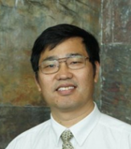 | 单宝珍 （Baozhen Shan）  CEO of Bioinformatics Solutions Inc.  单宝珍博士是加拿大Bioinformatics Solutions Inc.（BSI）的首席执行官，是PEAKS算法的设计开发核心成员。BSI是全球领先的蛋白质组学软件和服务平台提供公司之一。单博士于2008年加入BSI。1997年，他从南京大学获得了他的第一个化学博士学位，2009年，他从Western Ontario大学获得了第二个计算机科学博士学位。目前，他的团队正在使用AI技术研究基于蛋白质组学的免疫治疗。  作为一名计算化学家，单博士在基于质谱的蛋白质组学的数据挖掘和统计分析(包括蛋白质/多肽鉴定和定量、抗体表征等)的相关研究和开发方面有超过15年的丰富经验。他发展了一套通过统计分析来建模和理解分子生物学的科学体系和算法。  Dr. Baozhen Shan is the CEO of BSI, one of the leading proteomics software and service platform providing companies. He began working at BSI in 2008. He obtained his first Ph.D in Chemistry in 1997 from Nanjing University, and his second in Computer Science in 2009 from University of Western Ontario. Currently, his team are working on the proteomics-based immunotherapy with AI technology.  As a computational chemist, he has spent more than 15 years in research and development related to data mining and statistical analysis of mass spectrometry-based proteomics (including protein/peptide identification and quantification, antibody characterization, etc.). As a result he has developed a broad set of scientific and algorithmic skills of modelling and understanding molecular biology through statistical analysis.
Hannes Röst

http://www.roestlab.org/index.html

多伦多大学(University of Toronto)

Hannes Röst在苏黎世联邦理工学院获得生物化学学士学位和生物信息学硕士学位，并在苏黎世联邦理工学院Ruedi Aebersold教授实验室获得博士学位，他开发了新的计算方法来分析基于质谱的蛋白质组学数据。这项工作使研究人员能够将目标蛋白质组学实验的通量提高100倍，并增加可在一项研究中分析的样本数量。获得博士学位后，他加入了斯坦福大学Mike Snyder教授的实验室，将他的工作应用于个性化医疗领域。在斯坦福大学，Hannes专注于开发用于处理的计算工具，管理和分析大型，异构和纵向数据集。他在多伦多大学的研究探索新的质谱方法，以获得高度定量的蛋白质组学和代谢组学数据矩阵，并使用这些定量数据来解决系统生物学和个性化医学中的问题。
Hannes Röst obtained a BSc in Biochemistry and a MSc in Bioinformatics from ETH Zurich, and during his PhD in the lab of Prof. Ruedi Aebersold at ETH Zurich, he developed novel computational methods to analyze mass spectrometry-based proteomics data. This work has allowed researchers to increase throughput of targeted proteomics experiments by up to 100-fold and increase the number of samples that could be analyzed in a single study. After his PhD, he joined the lab of Prof. Mike Snyder at Stanford University to apply his work in the area of personalized medicine. In Stanford, Hannes focused on developing computational tools for handling, managing and analyzing large, heterogeneous and longitudinal datasets. His research at University of Toronto explore the capability novel mass spectrometric methods to obtain highly quantitative proteomics and metabolomics data matrices and use these quantitative data to address questions in systems biology and personalized medicine.
Brian Searle

brian.searle@systemsbiology.org

https://systemsbiology.org/bio/brian-searle/

西雅图系统生物学研究所(Institute for Systems Biology, Seattle)

Brian Searle是系统生物学研究所的转化研究员。Brian于2001年在里德学院获得化学学士学位。2004年，他与Mark Turner和Ashley McCormack博士共同创办了Proteome Software，为蛋白质组学家制作和分发尖端的数据分析软件。2014年，他回到学术界，在华盛顿大学获得Michael MacCoss博士的博士学位，在那里他开发了使用质谱法检测和定量蛋白质和磷酸盐的方法。2018年，他作为独立研究员加入了系统生物学研究所，建立了一个研究项目，该项目弥合了基因组学和蛋白质组学技术之间的差距，以研究人类遗传变异。他广泛的研究兴趣跨越蛋白质组学，质谱，生物信息学以及解释氨基酸变异对单蛋白组和间蛋白组水平的影响的技术发展。
Brian Searle is a Translational Research Fellow at the Institute for Systems Biology. Brian received his chemistry BA at Reed College in 2001. In 2004, he co-founded Proteome Software with Mark Turner and Dr. Ashley McCormack to produce and distribute cutting-edge data analysis software for proteomicists. In 2014, he returned to academia to earn his PhD with Dr. Michael MacCoss at University of Washington where he developed methods to detect and quantify proteins and phosphosites using mass spectrometry. In 2018, he joined the Institute for Systems Biology as an independent fellow to build a research program that bridges the gap between genomic and proteomic technologies to study human genetic variation. His broad research interests span the intersection of proteomics, mass spectrometry, bioinformatics, and technology development to interpret the effects of amino acid variants on both a single- and a meta-proteome level.
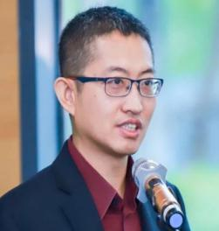 | 赵剑飞(Jianfei Zhao)  NEJM医学前沿(NEJM Frontiers in Medicine)  《NEJM医学前沿》副主编，全面负责杂志出版方面的相关运作，包括内容运营管理、战略规划和品牌推广。此前，在自然杂志社旗下的《自然通讯》杂志担任专职科学编辑，审阅来自世界各国的表观遗传学等生物领域论文。作为自然杂志社首位落地中国的生命科学领域编辑，与中国生命科学界的科研人员建立了密切联系。本科毕业于北京大学，在美国俄勒冈大学获得博士学位，随后在美国国立癌症研究所从事博士后研究，专注于表观遗传因素对基因表达调控的影响。  Deputy Editor, NEJM. Responsible for the daily operation of the digital platform, including content operation, strategic planning and outreach. Previously, he was a scientific editor at Nature Communications, Nature Publishing Group (NPG), managing the evaluation and review of manuscripts in biology, focusing on epigenetics, submitted around the world. As the first biology editor of NPG working in China, he fostered close relationships with the life sciences community in China. He obtained a B.Sc in Peking University, and a Ph.D. in University of Oregon, the United States. His postdoctoral training in the US National Cancer Institute is centered on the epigenetic regulation of gene expression.
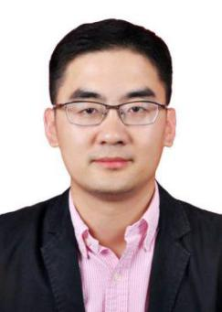 | 李文庆(Wenqing Li)  北京大学肿瘤医院、北京大学国际癌症研究中心(Peking University Cancer Hospital and Peking University International Cancer Research Center)  北京大学肿瘤医院研究员、博士生导师、北京大学国际癌症研究中心PI。美国哈佛医学院和国立癌症研究所博士后，归国前任常青藤名校布朗大学助理教授、博士生导师。2016年入选中组部国家“千人计划”青年人才，2018年入选北京市“海聚工程”全职工作类，获聘为北京市特聘专家。现任中国抗癌协会青年理事会副理事长、北京抗癌协会青年理事会副理事长兼秘书长、中国抗癌协会肿瘤流行病学专委会以及胃癌专委会基础与病理学组委员、中国环境诱变剂学会生物标志物专委会委员和青委会副主任委员。  PhD. Principal Investigator at the Peking University Cancer Hospital and Peking University International Cancer Research Center. Before returning to China, he was an assistant professor at Brown University. He is the Vice Chair of the Youth Council of the China Anti-Cancer Association, the Vice Chair and Secretary General of the Youth Council of the Beijing Anti-Cancer Association, a member of the Cancer Epidemiology Committee and the Basic Research and Pathology Group of the Gastric Cancer Committee of the China Anti-Cancer Association, and a member of the Environmental Mutagen Society Biomarker Committee and Deputy President of its Youth Committee. He has been awarded several prestigious awards, including “Young One Thousand Talents Program” and “Beijing Haiju Project” (full-time employment category). He was a postdoctoral fellow at the Harvard Medical School and the US National Cancer Institute.
Limsoon Wong

limsoon@nus.edu.sg

https://www.comp.nus.edu.sg/~wongls/

National University of Singapore

Limsoon Wong is Kwan-Im-Thong-Hood-Cho-Temple Chair Professor in the School of Computing at the National University of Singapore (NUS). He was also a professor (now honorary) of pathology in the Yong Loo Lin School of Medicine at NUS. Before coming to NUS, he was the Deputy Executive Director for Research at A*STAR's Institute for Infocomm Research. He currently works mostly on knowledge discovery technologies and their application to biomedicine. He has also done, in the earlier part of his career, significant research in database query language theory and finite model theory, as well as significant development work in broad-scale data integration systems. Limsoon has written about 300 research papers, some of which are among the best cited of their respective fields. Limsoon is a Fellow of the ACM, named in 2013 for his contributions to database theory and computational biology. Some of his other recent awards include the 2003 FEER Asian Innovation Gold Award for his work on treatment optimization of childhood leukemias, the 2006 Singapore Youth Award Medal of Commendation for his sustained contributions to science and technology, and the ICDT 2014 Test of Time Award for his work on naturally embedded query languages. He was also conferred, in 2014, a Public Administration Medal (Bronze) by the Singapore Government for outstanding efficiency, competence, and industry. He serves/served on the editorial boards of Journal of Bioinformatics and Computational Biology, Bioinformatics, Biology Direct, Drug Discovery Today, IEEE/ACM Transactions on Computational Biology and Bioinformatics, Genomics Proteomics & Bioinformatics, Journal of Biomedical Semantics, Methods, Scientific Reports, Information Systems, and IEEE Transactions on Big Data. He is also an ACM Books Area Editor. Limsoon received his BSc(Eng) in 1988 from Imperial College London and his PhD in 1994 from University of Pennsylvania.
吴健民(Jianmin Wu)

https://www.researchgate.net/profile/Jianmin_Wu3

北京大学肿瘤医院、北京大学国际癌症研究中心(Peking University Cancer Hospital and Peking University International Cancer Research Center)

吴健民，研究员、博士研究生导师，北京大学肿瘤医院肿瘤生物信息中心主任，兼信息部副主任。致力于综合计算和实验手段，整合多组学和临床数据深入研究国内高发癌种的发病机制、精准分子分型和个体化治疗。担任国际癌症基因组联盟(ICGC) 癌症基因组加速研究计划（ARGO）委员会委员，在大队列的癌症基因组、蛋白组及相关生物信息学研究上有丰富经验。通讯作者研究成果先后在Nature Methods、Nature Reviews Cancer (Analysis Article，封面文章)、Nucleic Acids Research 等杂志发表；合作研究多次在Nature (4次)和Cell (2014)等杂志发表。共发表SCI论文40余篇，他引大于2000次，单篇最高引用775次。
Director of Cancer Bioinformatics Center, Peking University Cancer Hospital. Dr. Wu is a senior bioinformatician focusing on data-driven cancer research, which combines high-throughput genomic, transcriptomic and proteomic profiling approaches, to comprehensively investigate molecular landscapes of GI cancer and identify prognosis/predictive biomarkers and novel therapeutic targets. He published 40+ publications in peer reviewed journals with >2000 citations, including corresponding author work in Nature Methods, Nature Reviews Cancer and Nucleic Acids Research et al. , and collaborative work in Nature (4) and Cell. He is also a scientific planning committee member of International Cancer Genome Consortium (ICGC) - Accelerating Research in Genomic Oncology (ARGO) initiative.
常乘(Cheng Chang)

https://orcid.org/0000-0002-0361-2438

国家蛋白质科学中心-北京(National Center for Protein Sciences (Beijing))

2010年毕业于湖南大学电子信息工程专业，获学士学位。2010年-2015年就读于北京蛋白质组研究中心，专业生物信息学。2015年博士毕业后任国家蛋白质科学中心-北京（凤凰中心）助理研究员，研究方向：生物信息学、蛋白质组学、系统生物学。自2015年以来，他已在无标定量、有标定量、差异蛋白质筛选、定量结果富集分析及可视化等方面提出了一系列新算法，研发了有标定量工具SILVER，蛋白质无标定量算法LFAQ，综合性定量软件包PANDA以及定量结果统计分析及可视化工具PANDA-view，蛋白质相互作用网络分析工具PPIExp，蛋白质相互作用文献挖掘工具PPICurator；主持国家自然科学基金青年项目一项、蛋白质组学国家重点实验室自主研究课题一项，参与973、863、国际科技合作、国家重点研发计划等项目多项，以第一及通讯作者（含共同）在Bioinformatics, Analytical Chemistry, Journal of Proteome Research, Proteomics等期刊上发表论文12篇，获得软件著作权授权6项，申请国家发明专利3项。曾获2016年第九届中国蛋白质组学大会“优秀青年学者报告奖”。
Dr Cheng Chang is an assistant research fellow at National Center for Protein Sciences (Beijing) focusing on bioinformatics, proteomics and system biology. Since 2015, Dr Chang has proposed novel algorithms and developed easy-to-use tools for both label-free and labeled quantifications, as well as the post-processes of quantification results, such as LFAQ for label-free absolute protein quantification and PANDA for both labeled and label-free quantitative proteomics data analysis. As the first or corresponding authors, he published 12 papers in journals such as Bioinformatics, Analytical Chemistry, Journal of Proteome Research, Proteomics, etc., and obtained 6 software copyright licenses. He was awarded the Young Investigator Award at the 9th CNHUPO in 2016.
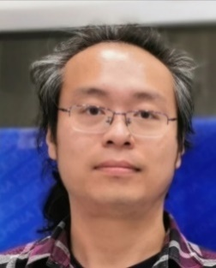 | 沈诚频（Chengpin Shen）  www.omicsolution.com  易算生物（Omicsolution）首席技术官  本科及博士就读于复旦大学化学系、生物医学研究院，MIT访问学者。自2005年起从事蛋白质组学相关研究工作，2016年创办易算生物，与瑞士Biognosys公司合作，在国内致力于推广基于SWATH/DIA技术的蛋白质组定量解决方案。  Dr Shen received his bachelor and PhD degree from Department of Chemistry, Institutes of Biomedical Sciences, Fudan University, and visiting scholar of Massachusetts institute of technology. He has been engaged in proteomics research since 2005 and established Omicsolution in 2016. With the cooperation with Biognosys from Switzerland, he popularized a total solution of quantitative proteomics based on SWATH/DIA technology in China.
陈晨(Chen Chen)

SCIEX

高级应用工程师，2015年于武汉大学获得生物化学与分子生物学博士学位。现就职于SCIEX中国应用支持团队，负责蛋白质组学的应用支持工作，拥有9年基于质谱的蛋白质组学研究经验。
Senior Application Engineer, Ph.D. in Biochemistry and Molecular Biology from Wuhan University in 2015. Currently working for SCIEX China Application Support Team, responsible for proteomics application support, with 9 years of experience in mass spectrometry-based proteomics research.
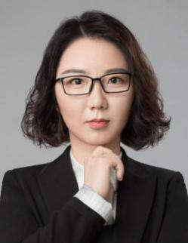 | 刘一颖(Yiying Liu)  SCIEX  应用工程师，复旦大学分析化学博士，生物医学研究院博士后。自2012年开始从事膜蛋白组学的研究，具有丰富的项目开发和故障排查经验。Application Engineer，PhD in Analytical Chemistry. Dr. Liu has engaged in the research of membrane proteomics since 2012 in Department of Chemistry & Institutes of Biomedical Sciences, Fudan University. She has extensive experience in method development and troubleshooting.
朱天生(Tiansheng Zhu)

http://www.guomics.com/nd.jsp?id=16#_jcp=1

西湖大学(Westlake University)

本硕毕业于华中农业大学作物生物技术专业，博士在读于复旦大学计算机软件与理论专业。2017年9月，作为资深科研助理加入西湖大学郭天南实验室，主要研究蛋白质组大数据的处理和分析。
Tiansheng received training of biotechnology in Huazhong Agricultural University (HZAU), and learned computer science in Fudan University, China. He worked on data management in the data center Department of Shanghai bioinformatics research center. After that, he was engaged in the construction and management of data platform in Shanghai Academy of Agricultural Sciences. Tiansheng joined the Guomics team in September 2017 as a senior research assistant, and mainly works in proteomic big data science.
陈浩(Hao Chen)

http://www.guomics.com/nd.jsp?id=73#_jcp=1

西湖大学(Westlake University)

陈浩在NGS行业工作6年，具有面向对象编程(c#、c++)和脚本编程(perl、R、Python或bash)方面的工作经验，擅长生物信息大数据分析平台建设，目前主要从事蛋白质组大数据挖掘工作。
Hao has worked in NGS industry for 6 years, with rich experience in object-oriented programming (C#,C++) and scripting (perl, R, Python and bash). He is good at building bioinformatics pipelines. Now he is working on proteomic data mining.
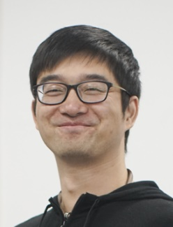 | 陆妙善(Miaoshan Lu)  西湖大学(Westlake University)  2010-2013年,创立南京魔韵软件科技有限公司,担任公司COO首席运营官；2008-2014年硕士研究生毕业于南京大学软件工程学院2014-2018年在阿里巴巴从事软件研发相关工作；2014-2015年在电子凭证交易团队担任研发工程师(P5)；2015-2016年分别在O2O团队和商品中心团队担任资深研发工程师(P6)；2016-2018年在国际化Lazada团队担任技术专家,移动端开发组Team Leader(P7)；2018年1月1日从阿里巴巴辞职,提前进入西湖大学于长斌实验室从事博士相关的工作；2018年9月正式进入西湖大学读博,成为西湖二期的成员。  Miaoshan founded nanjing moyun software technology co., ltd and served as the COO of the company(2010-2013) and learned software engineering(2008-2014)in Nanjing University. In 2014, Miaoshan started his 4 years career as software researcher in alibaba. He worked as a software researcher(P5) in the electronic certificate trading team(2014-2015), and served as senior engineer in O2O(Online to Offline & Offline to Online) team and alibaba commodity center team respectively. From 2016 to 2018, he worked as a technical expert in the international Lazada Team and the Team Leader of the Lazada-Seller-MobileTeam. He resigned from alibaba in 2018.1.1, and entered Westlake University to do PhD related work ahead of schedule. In 2018.9, He officially entered the Westlake University as a doctoral candidate and became a member of the Phase 2 of Westlake University.
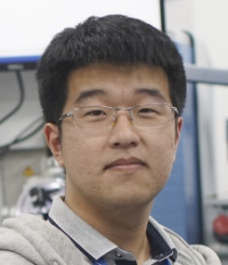 | 王瑞敏(Ruimin Wang)  西湖大学(Westlake University)  西湖大学-复旦大学2017级跨学科联合培养攻读博士学位研究生，人工智能与机器人中心于长斌实验室首批博士生，2017年毕业于中国科学技术大学计算机科学与技术专业，主要研究方向是质谱数据的分析算法。Ruimin received bachelor's degree in Computer Science from University of Science and Technology of China in 2017 and joined Westlake University as a PhD student, mainly engaged in analyzing algorithm of MS data.
郑钜圣 (Jusheng Zheng)

http://www.wias.org.cn/wap/index.php?a=kydetail&catid=490&id=8792&web=english

西湖大学(Westlake University)

2009年毕业于宁波大学，获得学士学位；2014年毕业于浙江大学，获得博士学位，从事营养流行病学研究；2011-2012年，作为联合培养博士生，在美国塔夫茨大学人类老年营养研究中心从事营养遗传学研究；2015年-2018年在英国剑桥大学临床医学院从事遗传流行病学和营养学博士后研究工作，欧盟玛丽居里学者（Marie Skłodowska-Curie Individual Fellow）。2018年9月加入西湖大学生命科学学院，担任独立课题组负责人（PI）、特聘研究员、博士生导师，成立人类营养与流行病实验室
Ju-Sheng completed his PhD degree in nutrition at Zhejiang University (Hangzhou, China). Within his PhD program, he received one year’s training in the Nutrition and Genomics Lab at Jean Mayer USDA Human Nutrition Research Center on Aging at Tufts University in the USA, where he worked on the project of gene-nutrient interaction on diabetes traits. He is also a Marie Skłodowska-Curie Individual Fellow supported by the European Commission (2016-2018), and receiving postdoctoral training at the MRC Epidemiology Unit, University of Cambridge, UK. Ju-Sheng joined the School of Life Sciences at Westlake University in September 2018 and has been leading the Laboratory of Human Nutrition and Epidemiology at Westlake University.
于长斌(Changbin Yu)

http://www.wias.org.cn/index.php?a=kydetail&catid=487&id=8516&web=chinese

西湖大学(Westlake University)

2004年毕业于新加坡南洋理工大学，获计算机工程一等荣誉学士学位；2008年毕业于澳洲国立大学，获工学博士学位并留校任教，历任讲师，高级讲师，特聘研究员，终身教授及网络化系统学科方向负责人；曾兼任澳洲国立大学工学院副院长，澳洲国家信息通信技术研究院主任研究员。现为西湖大学人工智能与机器人中心负责人(PI)。

In 2004, he graduated from nanyang technological university, Singapore with first-class honors degree in computer engineering. Graduated from the Australian national university in 2008, obtained a doctor's degree in engineering and taught at the university. He has been a lecturer, senior lecturer, distinguished researcher, tenured professor and principal of networked systems discipline.He is also the deputy dean of the faculty of engineering of the Australian national university and the chief research fellow of the Australian national institute of information and communication technology.Now he is the director of artificial intelligence and robot center (PI) of westlake university.
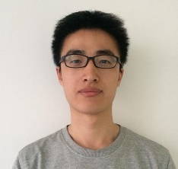 | 曾文锋(Wenfeng Zeng)  中国科学院计算技术研究所，pFind实验室  pFind Lab, Institute of Computing Technology (ICT), CAS  博士毕业于中科院计算所pFind实验室，现为中科院计算所助理研究员。主要研究方向为基于质谱技术的计算蛋白质组学研究，包括蛋白质搜索引擎和糖蛋白质搜索引擎，以及基于机器学习的质谱数据分析方法。开发了糖蛋白质搜索引擎pGlyco、pGlyco2和基于深度神经网络的肽段理论谱图预测方法pDeep、pDeep2。  Dr. Zeng received his Ph.D. degree from pFind Lab at ICT, CAS, and he is now an assistant researcher at ICT. His research interests focus on mass spectrometry (MS)-based computational proteomics, including design of protein/glycoprotein search engines, and machine learning-based methods for interpreting MS data. He has developed glycoprotein search engine pGlyco/pGlyco2, and deep neural network-based methods, pDeep/pDeep2, for the prediction of tandem mass spectra of peptides.
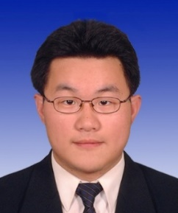 | 张青(Qing Zhang)  布鲁克公司 (Bruker Daltonic)  布鲁克公司高级应用工程师，毕业于上海交通大学（生物信息学专业）。从业近10年，长期从事蛋白质组学相关科研及应用开发工作。曾任上海生物信息技术研究中心质谱工程师，负责支持蛋白质组学技术开发及数据挖掘工作。现为布鲁克公司高级应用工程师，负责布鲁克公司高分辨质谱（FTMS及timsTOF Pro）应用支持工作。  Senior application scientist in Bruker China, is graduated from Shanghai Jiaotong University majoring in Bioinformatics. After graduation Qing has about 10 years hand-on experience on mass spectrometry based proteomics and its data mining. He used to be an engineer in Shanghai Center for Bioinformation and Technology (SCBIT), supporting mass spectrometry based proteomics and data mining. Now he is working for Bruker China, supporting for ultra-high resolution mass spectrometer including FTMS and timsTOF Pro in China.
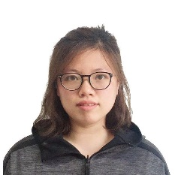 | 黄敏（Min Huang）  Thermo Fisher Scientific  赛默飞生命科学质谱高级应用工程师，负责蛋白组学、结构生物学相关的质谱技术开发与应用支持。  The senior application engineer of mass spectrometry for life sciences of Thermo Fisher, responsible for the development and application support of structural biology of proteomics mass spectrometry。

